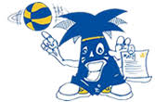RMS PAC needs YOUR Help
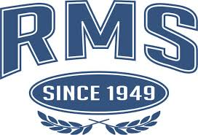
To build our schools spirit we would like to come up with a hashtag that represents our school, students and staff.

We are asking that the students come up with this #hashtag.

The PAC executive will then pick the top 3 and have the students vote on these.

The #hashtag will then be placed on Spirit wear (t-shirts, hoodies etc.,) that can be purchased by students, staff, and family.

We hope this project will give everyone a sense of pride about themselves and the school they go to. We believe the students, staff and teachers define our school.

Please place your idea below and submit to your teacher.

Hashtag: #_______________________________________________

Name of student: _________________________________________

Teacher: _________________________________________________
DEADLINE – Friday September 27th

